CUIMC MealPlan User Guide

Table of Contents

Introduction 1

Running CUIMC MealPlan 1

Using CUIMC MealPlan 1

New ID Card 3

UNI Not Found 4

Duplicate Check-In 5

Out of Meals 5

# Introduction

CUIMC MealPlan (MP) is a system to assist Faculty Club in administering diner check-in in the student dining plan. It is composed to two modules, a staff module for checking-in diners, and an administrative module for reporting and database maintenance.

# Running CUIMC MealPlan

To run MealPlan (MP), double click on its icon.



# Using CUIMC MealPlan

The MP application runs in a simple loop.

1. It asks for a diner identifier, either a UNI or an ID Card number.
2. If the diner is found in the database, it shows information about the diner, including the number of meals available. It asks the user to confirm checking-in for the meal.
3. If the user checks-in, it displays revised meal information.
4. Either way, it asks for a new diner identifier.

Upon startup, you should see this screen:

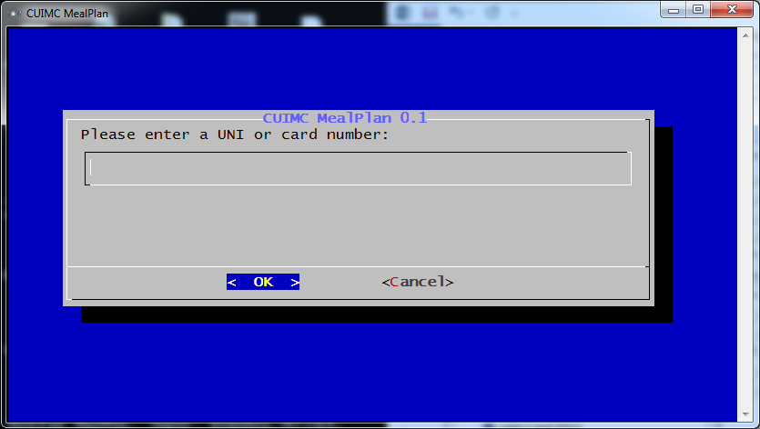

To begin the check-in process, either scan and ID card, or type in a UNI and press Enter.

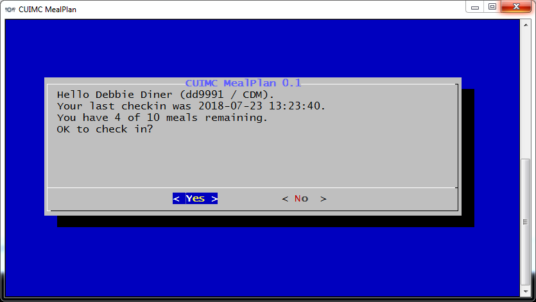

There are several pieces of important information on this screen:

1. The name, UNI, and school affiliation of the user,
2. The date of the last check-in, and
3. The number of meals remaining.

At this point, press Enter to check this diner in. Press Esc, or Tab to the No button and press Enter, to look for another diner.

After check-in, you will see this confirmation screen. Note that the number of meals remaining has decreased. You are ready to enter another diner identifier.

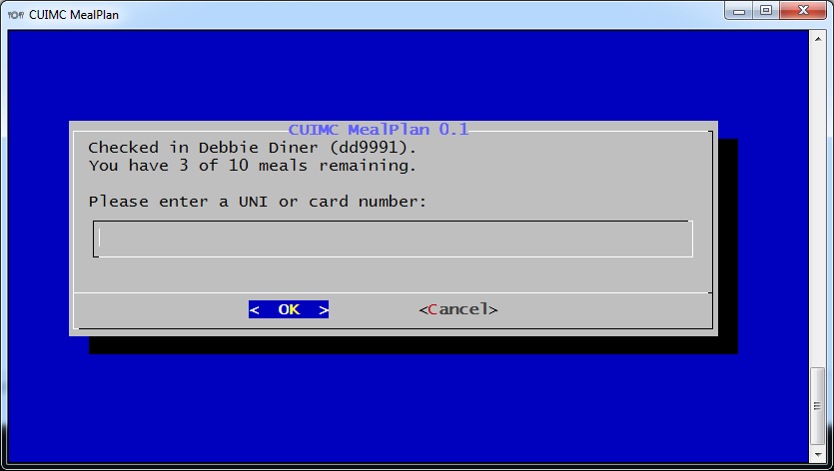

On any screen asking for a “UNI or card number”, you can exit MP by selecting Cancel.

## New ID Card

If you scan an ID card and that card is not linked to a UNI, you will see the following.

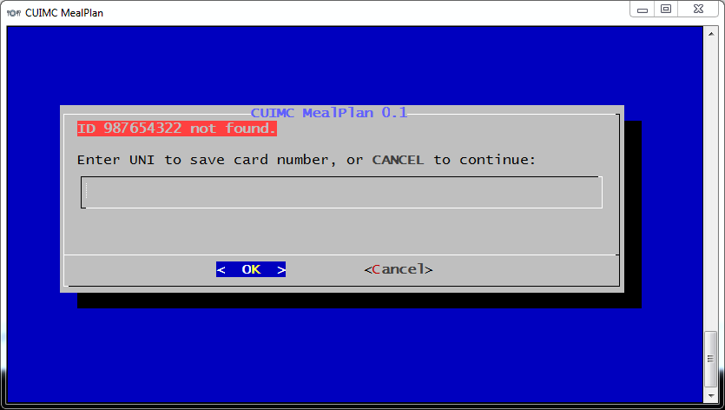

Type the diner’s UNI and press Enter. You will see a confirmation.

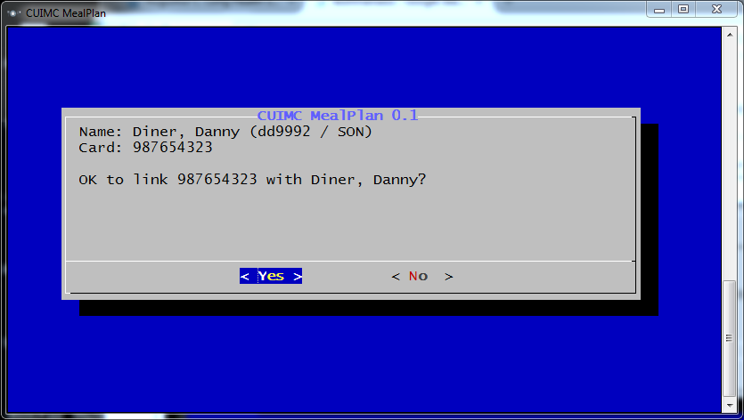

Press Enter to link the card number with the diner, or select No. If you select Yes, MP will proceed to confirm check-in.

## UNI Not Found

If you enter a UNI not in the database, you will see a screen like the following.

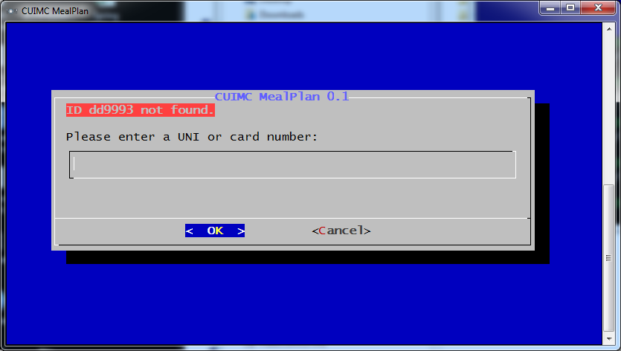

## Duplicate Check-In

If a diner has already checked-in today, the system will beep and notify you.

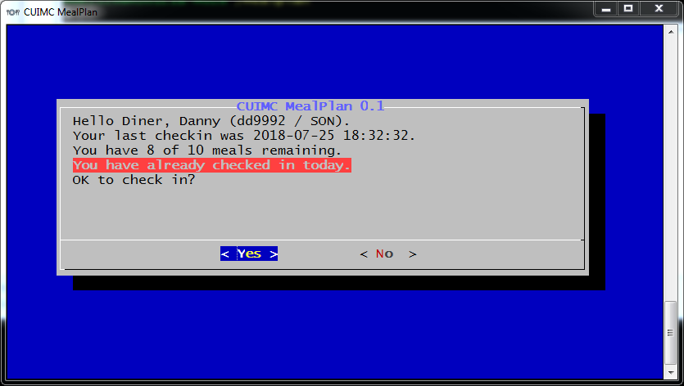

You may select Yes to check the user in again, or No to cancel the check-in.

## Out of Meals

If the diner is out of meals, you will see the following and you will be unable to check them in.

